**BIS**

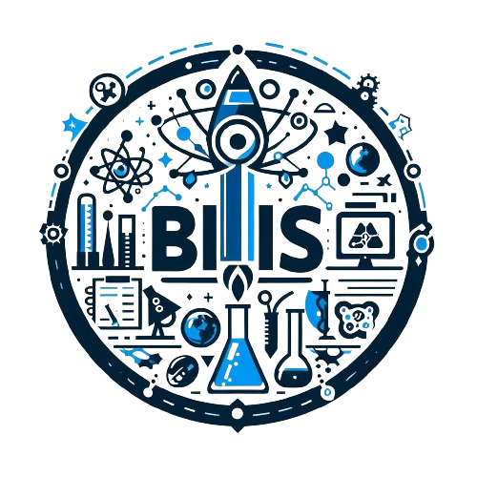

**CONTENTS**

1. TEAM MEMBERS 3

1.1 NAMES AND ROLES 3

2. ABOUT BIS 3

3. PERFORMED TASKS 4

4. TOOLS ANS LANGUAGES 5

5. SOURCES 6

5.1 OUR SOURCES: 6

# Team MEMBERS

## NAMES AND ROLES

|  |  |
| --- | --- |
| Name | Role |
| Alexander Harakchiyski | *SCRUM trainer* |
| Daniel Hristov | *Q&A* |
| Miroslav Markov | *Back-end developer* |
| Ivo Badalov | *Back-end developer* |
| Stanislav Dzheneviz | *Back-end developer* |
| Stiliyan Mishev | *Back-end developer* |

# ABOUT BIS

Experience the educational revolution with BIS, where each of our three tests features 50 questions covering Biology, Physics, and Chemistry. Dive deep into the world of science and challenge your knowledge across multiple disciplines. Join us and redefine the way we approach education with BIS.

At BIS, we're committed to shaping well-rounded scholars through our comprehensive tests, each comprising 50 question. With BIS, students don't just learn science; they engage with it, fostering a deeper understanding and appreciation for the world around them. Choose BIS for assessments that inspire curiosity and fuel academic excellence.

# PERFORMED TASKS

|  |  |
| --- | --- |
| № | Completed tasks |
| 1 | *We decided what our app is going to be about* |
| 2 | *We made the logo* |
| 3 | *The Back-end developers made the tests* |
| 4 | *There were some small mistakes that we fixed* |
| 5 | *The Q&A tested our application* |
| 6 | *Miroslav made the documentation* |
| 7 | *Alexander made the presentation* |

# tools and languages

|  |  |
| --- | --- |
|  | We used Visual Studio as our code editor |
|  | We used C++ to code our application |
|  | We used Word to make our documentation |
|  | We used PowerPoint to make our presentation |
|  | We used Teams to share our progress of the project |
|  | We used GitHub for source control and task management |
|  | We used Git for collaborating with each other on the project |

# 

# Sources

The information we used came from different places. We carefully chose our sources and read all of the information. That’s why we think it’s suitable for our readers. Anybody, who wants to have fun and enjoy learning and testing their knowledge can take our test!

## 5.1 our sources:

<https://www.wikipedia.org/>

<https://www.w3schools.com/>

<https://github.com/>

<https://fonts.google.com/>